|  |  |
| --- | --- |
| **موضوع پروژه**: وب سایت گالری عکس | **نام پروژه**:Snap Pic |
| **عنوان سند**:Use Case Diagram | **تاریخ**:96/08/16 |

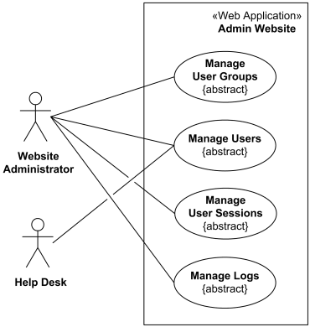

Sing In

Forgot Password

Public User

Securtiy Questin

Sing Up

Register

Picture

Pictures

Gruops

Login

Comment

Sing In

Securtiy Questin

Sing Up

Register

Delect Picture

Groups Management

Login



Admin User

Create Group

Forgot Password

Delect Picture

Create Picture

New Picture

New Group

Pictures Management